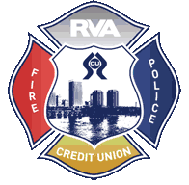
RVA-FPCU Online Banking Instructions
Welcome to RVA-FPCU’s new and improved Online Banking system, below you will find detailed instructions on how to enroll. Contact a Member Service Rep. for questions at 804-354-0673.
Note: RVA-FPCU also offers an app available for free download via the App Store and Google Play. You must enroll in Online Banking before you can access the app. Your login information will be the same for both products.
- Open the internet on your electronic device, and type in our website (www.firepolicecu.org) in the search bar.
- In the box that reads, “ONLINE BANKING”, please enter your member number in the top box and the last four digits of your SSN on the bottom line, then push submit.
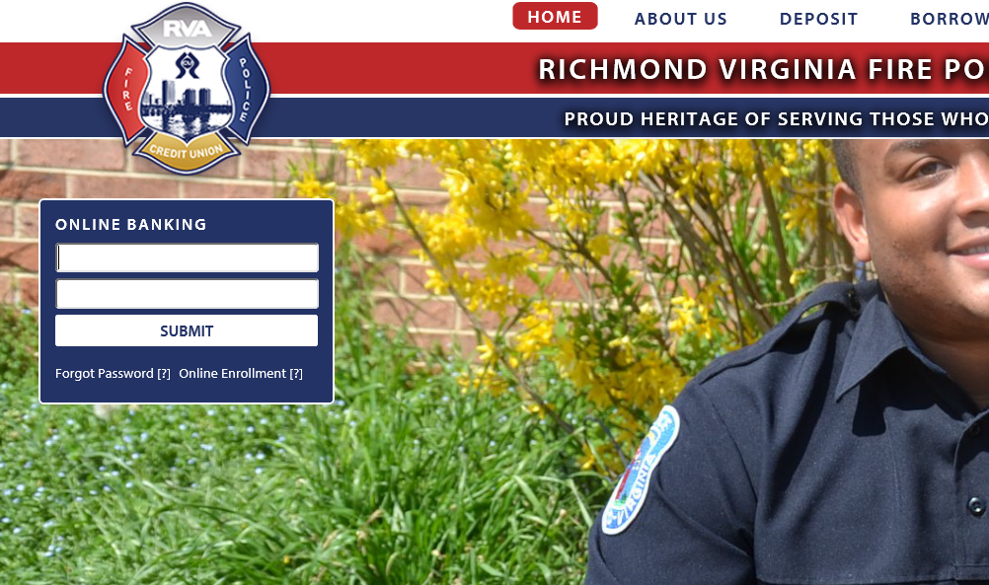

- Next, you will see a prompt to “Secure Your Account”.
  - Choose a security imagine from the ones provided
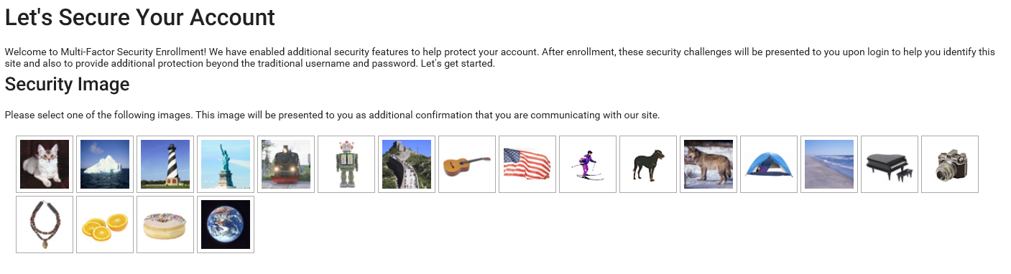

  - Choose your challenge questions and verify them a second time.
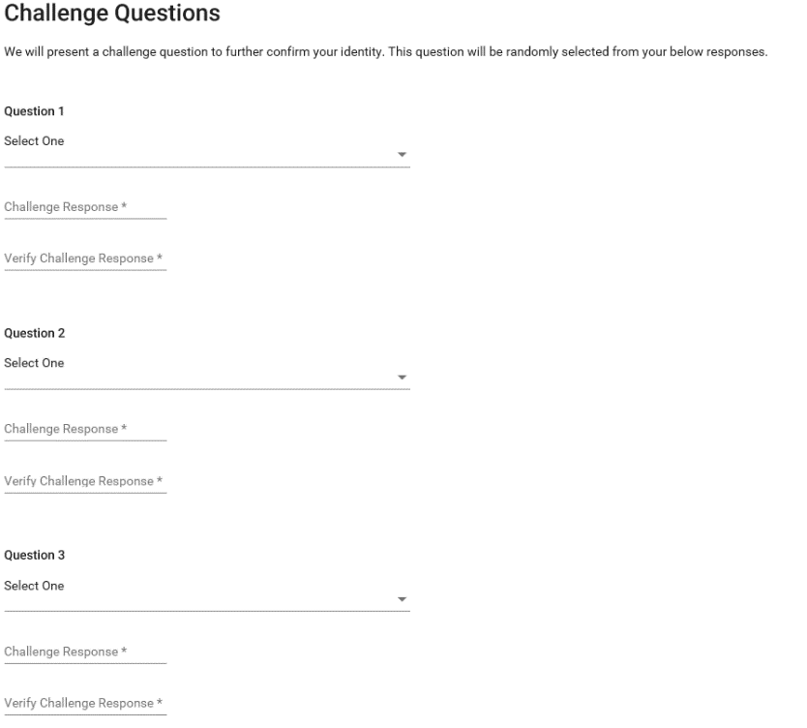
  - Choose a word (any word that you will easily remember) for the capture.
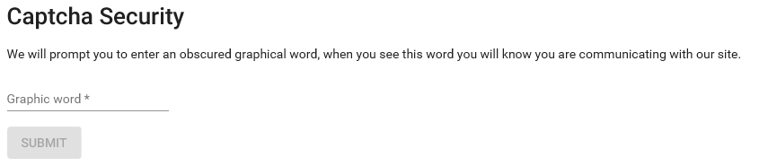

- The system will then ask you to create your own password.
IMPORTANT: Please be sure to make note of all images, passwords, challenge questions etc. that you create, because you may need them in the future.
Once you’re logged in, it’s also important to name and register your personal device through “Device Management”. Do not register public devices, which other individuals can access.

- Next, you should have full access to your account information.
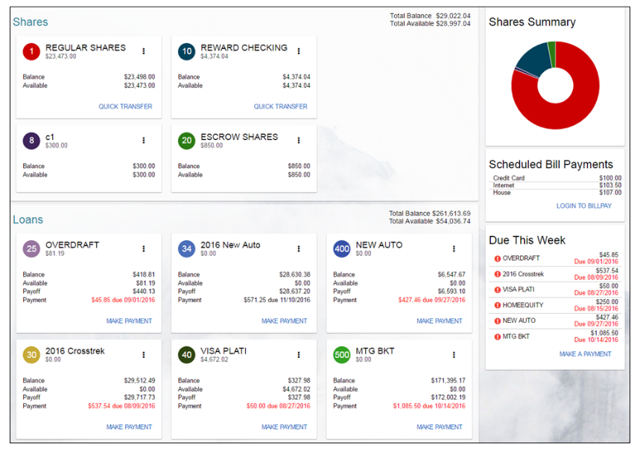
- Most services and products (including Bill Play) are accessible through the Main Menu tab, which is located on the top left corner of the page. You can also change your username, through “Settings”.
